**AI introduction assignment 2 – A* algorithm**

**Part 1**: same cost tiles, grid with obstacles

**Task** 1:

The shortest path is indicated by the yellow line.

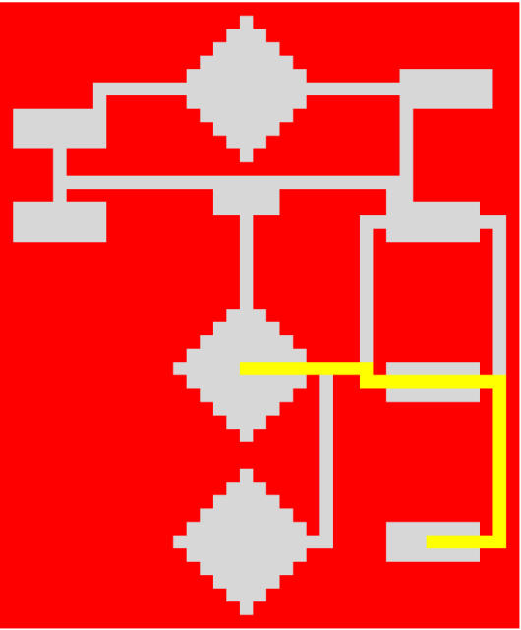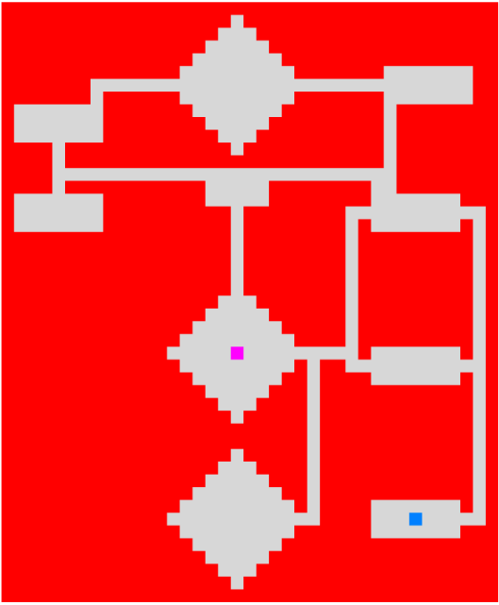

**Task2:**

The shortest path is indicated by the yellow line.

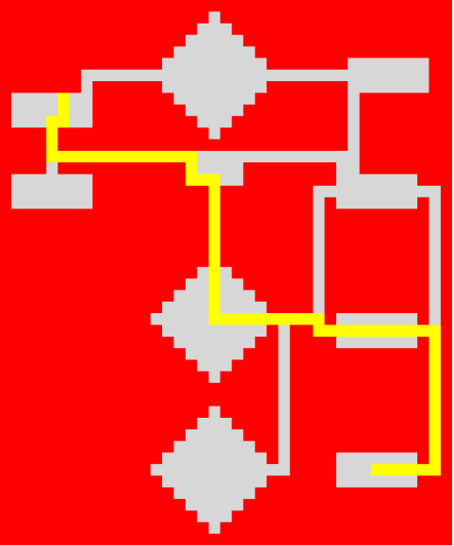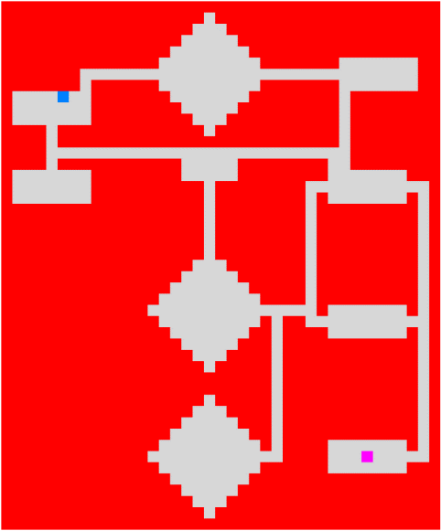

**Part 2:** Different cost on tiles

**Task 3:** The shortest path is indicated by the yellow line.

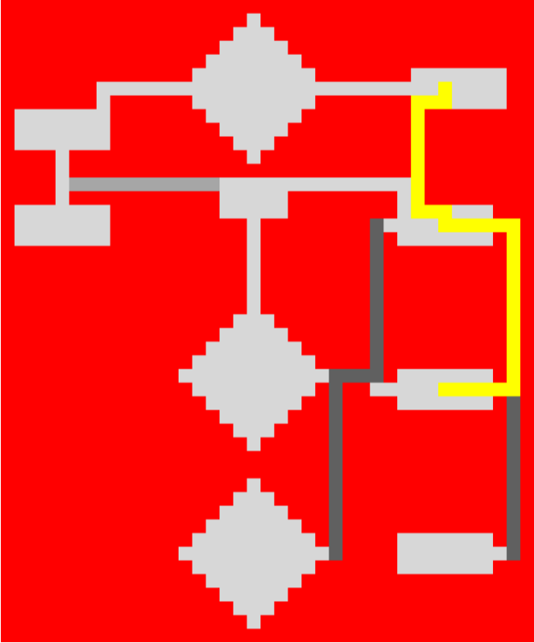

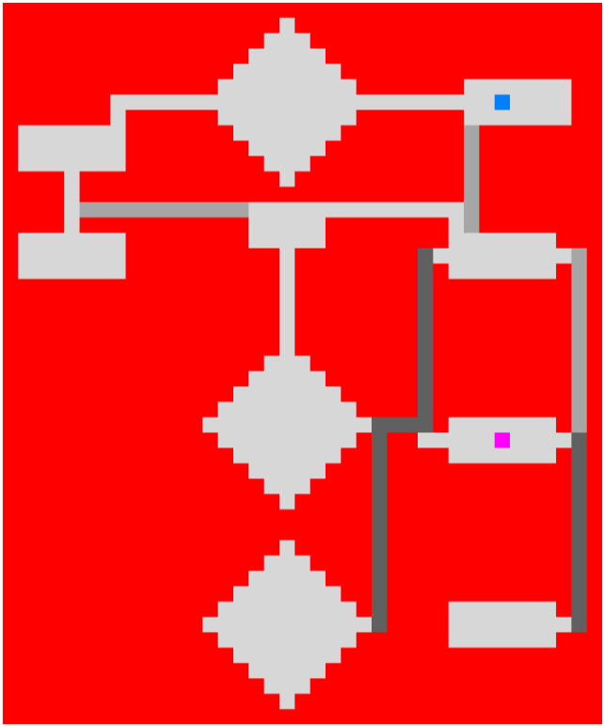

**Task 4:** The shortest path is indicated by the yellow line.

